Name: Madhu Balan I
Reg no:192321142
Course: Computer Vision

CO5 ASSESSMENT 1
CONSTRAINT-BASED PROBLEM SOLVING

1. Real-Time Face Recognition for Campus Security
Question: A university wants a camera-based security system at the entrance that identifies registered students and staff in real time under different lighting conditions, extracts suitable facial features, recognises registered individuals, runs on a low-cost computer, and minimises false recognition. Design a complete OpenCV-based face-recognition pipeline and justify how it achieves accuracy and real-time performance.
Answer:

The proposed solution is a gated identification pipeline rather than a system that attempts to recognise every face unconditionally. Each camera frame is acquired, normalised, searched for faces, converted into a compact numerical representation, compared with an enrolled gallery, and accepted only when the similarity score and quality checks meet defined thresholds. This separation between detection, feature extraction, and identity decision makes the system easier to test and reduces the chance that a poor-quality face crop will create a false match.
Image acquisition begins with cv2.VideoCapture connected to the CCTV stream. The system should request a modest resolution, such as 640 × 480, because very high resolution increases computation without necessarily improving recognition at the entrance distance. Frames are timestamped, and a small capture queue prevents the display thread from blocking the processing thread. If the camera disconnects, the system records the failure and attempts reconnection rather than silently producing missing results.
Preprocessing improves the stability of the face detector. The frame is converted to a suitable colour representation and optionally downscaled for detection. Brightness is normalised using techniques such as gamma correction or CLAHE on the luminance channel. CLAHE should be limited to avoid amplifying sensor noise. A small bilateral or Gaussian filter can suppress noise while preserving facial boundaries. The pipeline should also reject frames that are excessively dark, saturated, blurred, or tilted, because recognition on unusable data increases false acceptances.
Face detection can use a Haar cascade for a lightweight baseline or an OpenCV DNN face detector for greater robustness to pose and illumination. The detector returns bounding boxes and confidence values. Non-maximum suppression removes duplicate overlapping boxes, and a minimum face-size rule prevents very small detections from entering the recognition stage. The system may also require a frontal or near-frontal pose because recognition quality falls when only a small portion of the face is visible.
For feature extraction, the preferred design is to use a face-embedding model accessed through OpenCV’s DNN module. Each detected face is aligned using eye or landmark positions, resized to the model input size, and converted into a fixed-length embedding vector. The vector is L2-normalised, so cosine distance or Euclidean distance can be used consistently. During enrolment, several good-quality images are collected for each registered person under different expressions and lighting conditions; their normalised embeddings are averaged or stored as a small gallery rather than relying on one photograph.
Recognition compares the live embedding against the registered gallery. The nearest identity is not automatically accepted: the best distance must be below a calibrated threshold, and the difference between the best and second-best candidate should be large enough to show separation. If the score is ambiguous, the system returns “unknown” and requests human review. This open-set decision is essential because forcing every face into a known identity would increase false recognition. A second confirmation across several consecutive frames further reduces one-frame mistakes.
Real-time performance on a low-cost computer is achieved through selective processing. The detector can run every second or third frame while a tracker follows the face between detections. Regions of interest can restrict processing to the entrance zone. Frames can be resized, the display can run in a separate thread, and the embedding model can be loaded once rather than recreated per frame. OpenCV’s DNN backend and target should be selected according to the available CPU, and profiling should measure capture time, detection time, embedding time, and total latency.
Accuracy should be evaluated using a held-out validation set containing different lighting, camera distances, head poses, and look-alike individuals. Important measures include false-accept rate, false-reject rate, detection recall, average processing time, and end-to-end latency. Thresholds must be selected from validation data rather than guessed. The system should store only the minimum necessary data, protect the enrolment database, log confidence and decision status, and provide a manual override because a camera-based result should not be treated as infallible evidence.
Stage | OpenCV-oriented implementation | Main constraint addressed
Acquisition | cv2.VideoCapture, timestamping, capture thread | Continuous live stream
Preprocessing | Resize, CLAHE/gamma, light denoising, quality checks | Lighting and sensor noise
Detection | Haar cascade or OpenCV DNN + NMS | Reliable face localisation
Features | Alignment + DNN embedding + normalisation | Identity discrimination
Decision | Nearest match, threshold, margin, temporal confirmation | False recognition
Optimisation | Frame skipping, ROI, tracker, profiling | Low-cost real-time hardware

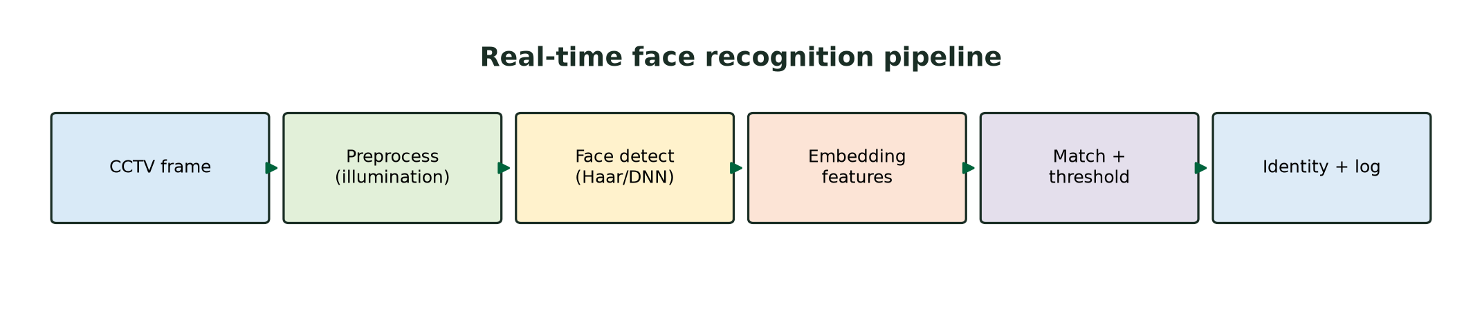
Figure 1. Recommended face-recognition pipeline from live CCTV acquisition to identity logging.

2. Intelligent Traffic Violation Detection System
Question: A traffic department wants to detect and track vehicles from roadside cameras, identify line crossings, count vehicles, detect abnormal movements, and display counts and alerts in real time. Design an OpenCV-based solution and explain how shadows, camera noise, dynamic backgrounds, and multiple vehicles are handled.
Answer:
The system should use a fixed-camera coordinate model and maintain a persistent track for each vehicle. The major stages are video acquisition, calibration and region-of-interest selection, vehicle detection, multi-object tracking, line-crossing logic, abnormal-motion analysis, and visualisation. Counting must be based on track events rather than simply counting foreground blobs in each frame; otherwise one vehicle would be counted repeatedly as it remains visible.
Video acquisition uses cv2.VideoCapture with a fixed frame size and a timestamp for each frame. A region of interest excludes sky, buildings, pavements, and unrelated areas. If the camera is not perfectly level, a perspective transform can map image coordinates to a bird’s-eye approximation, making speed and direction comparisons more meaningful. The virtual counting line is placed inside the road region, away from the image boundary, and its direction is defined by the sign of a vehicle centroid’s movement relative to the line.
Preprocessing can include mild Gaussian or median filtering to reduce sensor noise and a brightness-normalisation step for gradual illumination changes. Vehicle candidates may be generated with background subtraction such as MOG2 or KNN, but a detector is more reliable when traffic is dense or the background changes. Depending on the available compute, the detector can be a lightweight OpenCV DNN model, with detection performed every few frames and a tracker used between detections. Morphological opening removes isolated noise; closing joins fragmented vehicle regions.
Each detection is represented by a bounding box, centroid, class label, and confidence. A tracker such as CSRT, KCF, or a multi-object association method predicts the next position. For multiple vehicles, detections are associated with existing tracks using intersection-over-union, centroid distance, and motion prediction. Each track receives a unique ID, a short history of centroids, a missed-frame counter, and a state such as tentative, confirmed, or lost. A track is not allowed to trigger a count until it has been observed consistently for several frames.
Line crossing is evaluated using the signed distance from the centroid to the counting line. If the sign changes from one side to the other and the motion direction agrees with the configured travel direction, the event is recorded once for that track ID. A cooldown or event flag prevents repeated counting while the same vehicle remains near the line. If a vehicle changes lanes or briefly disappears behind another vehicle, the track can be retained for a limited number of missed frames, but it should be deleted when its uncertainty becomes too large.
Abnormal or unwanted movement is defined explicitly rather than left to subjective visual judgement. Examples include a vehicle moving against the permitted direction, stopping inside a restricted zone for longer than a time threshold, reversing, making an impossible lateral jump, or exceeding a calibrated speed estimate. The system should require temporal evidence over multiple frames and attach the evidence track, time, direction, and confidence to each alert. This avoids generating an alert from a single noisy detection.
Shadows are reduced by using a shadow-detection option in MOG2 where appropriate, comparing colour and brightness relationships, and requiring a candidate to have a plausible vehicle shape and temporal persistence. Camera noise is reduced by filtering and by rejecting tiny connected components. Dynamic backgrounds such as trees are handled by a carefully tuned adaptive background model, a road-region mask, and an object detector that recognises vehicles rather than treating every moving pixel as a vehicle. Sudden camera movement should trigger model reinitialisation or a temporary suspension of counts.
The display overlays bounding boxes, track IDs, the virtual line, direction arrows, counts by class or direction, and alert messages. Accuracy is assessed with manually reviewed video using counting error, missed-vehicle rate, false-count rate, ID switches, and alert precision. Thresholds for confidence, missed frames, line crossing, and abnormal duration must be calibrated on representative daylight, night, rain, and high-traffic footage.
Problem source | Mitigation | Why it reduces errors
Shadows | Shadow-aware background subtraction, colour checks, persistence | Prevents shadows becoming vehicle blobs
Sensor noise | Median/Gaussian filtering, minimum component size | Removes isolated pixel changes
Dynamic background | Adaptive model + road ROI + detector confirmation | Separates trees and reflections from vehicles
Occlusion | Track retention, motion prediction, re-association | Preserves identity during brief disappearance
Repeated counting | Track-ID event flag and line-crossing sign change | Counts one crossing once
False alerts | Multi-frame confirmation and calibrated thresholds | Rejects one-frame anomalies

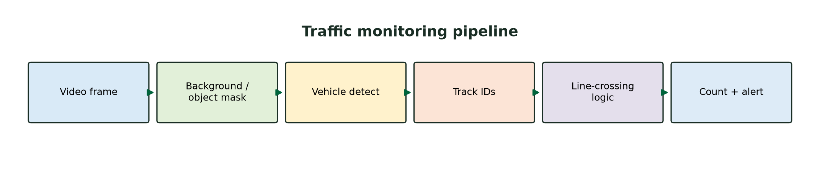
Figure 2. Traffic-monitoring pipeline using detection, tracking, signed line-crossing events, and alert logic.

3. Automated Document Processing System
Question: A company receives large numbers of scanned documents containing blurred text, uneven illumination, noise, and different font sizes. Design an OpenCV-based image-processing pipeline that improves quality, removes background, prepares images for OCR, segments text, and operates in batch mode. Explain how grayscale conversion, thresholding, filtering, morphology, segmentation, and geometric correction improve OCR accuracy.
Answer:
The document-processing system should treat OCR as the final stage of a quality-controlled image pipeline. Each input is assigned an identifier and processed through the same reproducible sequence, while quality metrics and intermediate outputs are logged. The pipeline should not apply one fixed threshold to every document because paper colour, scanner lighting, font size, and page layout vary considerably.
In batch mode, files are read from an input directory, validated for supported formats, and converted into a standard internal representation. OpenCV functions such as cv2.imread and cv2.cvtColor provide acquisition and colour conversion. The original file is preserved, while a processed copy is written to an output directory. A worker queue can process documents in parallel when memory allows, but the number of workers should be limited so that the OCR stage does not exhaust system resources.
Grayscale conversion reduces a colour image to luminance information, making subsequent filtering and thresholding simpler and faster. If coloured stamps or highlights carry meaning, the colour image should also be retained for a separate analysis path. Contrast can be improved globally with histogram equalisation or locally with CLAHE. Local contrast enhancement is often better for uneven illumination because it brightens dark regions without over-amplifying the entire page.
Filtering removes noise that would otherwise be mistaken for character strokes. Median filtering is useful for isolated salt-and-pepper noise, while Gaussian filtering reduces high-frequency sensor noise before thresholding. The kernel size must remain small relative to the stroke width; excessive smoothing can erase punctuation and thin characters. For blurred scans, mild sharpening or an unsharp-mask operation can improve edges, but aggressive sharpening creates halos that harm OCR.
Thresholding converts the grayscale image into a binary representation in which text is separated from the page. A global threshold such as Otsu works when illumination is uniform. Adaptive mean or Gaussian thresholding is more appropriate when the page contains shadows or gradients. The thresholded image should be checked for inverted polarity, because many OCR engines expect dark text on a light background. Threshold selection should be evaluated by OCR confidence and character error rather than by appearance alone.
Morphological operations correct the shape of the binary text. Opening removes small isolated noise, while closing fills tiny gaps within characters and joins broken strokes. A horizontal structuring element can connect words or line fragments for line segmentation, whereas a smaller rectangular element is safer for preserving individual characters. Morphology should be applied conservatively because over-closing can merge neighbouring words and produce incorrect OCR boxes.
Geometric correction is essential when the page is rotated, skewed, or photographed at an angle. The system can detect the largest document contour, approximate its four corners, and use cv2.getPerspectiveTransform with cv2.warpPerspective to rectify the page. For ordinary scans, skew can be estimated from text-line orientation and corrected by an affine rotation. Deskewing makes text baselines horizontal, improving both segmentation and recognition.
Segmentation divides the page into meaningful regions. Connected components, contours, projection profiles, and morphological line extraction can identify text blocks, columns, tables, and headings. Each region is processed at a suitable scale so that small text is not lost during global resizing. Regions should be ordered according to reading direction before OCR. Layout metadata, bounding boxes, OCR confidence, and page numbers should be retained so the extracted text can be traced back to its source.
The batch pipeline should include a quality gate. Pages with very low contrast, severe blur, extreme skew, or too little detected text are flagged for a second processing configuration or human review. This is preferable to silently returning unreliable text. Performance can be improved by caching intermediate results, using grayscale arrays where colour is unnecessary, processing pages independently, and avoiding repeated model initialisation. Accuracy is measured with character error rate, word error rate, text-region recall, and processing time per page.
Stage | Typical OpenCV operation | Effect on OCR
Grayscale | cv2.cvtColor | Simplifies luminance-based processing
Contrast | CLAHE or histogram equalisation | Reveals text under uneven illumination
Denoising | Median/Gaussian filtering | Removes noise without large artefacts
Thresholding | Otsu or adaptive threshold | Separates text from background
Morphology | Opening/closing with tuned kernels | Repairs strokes and removes specks
Geometric correction | Deskew + perspective warp | Straightens baselines and page geometry
Segmentation | Contours, connected components, projections | Provides clean text regions to OCR

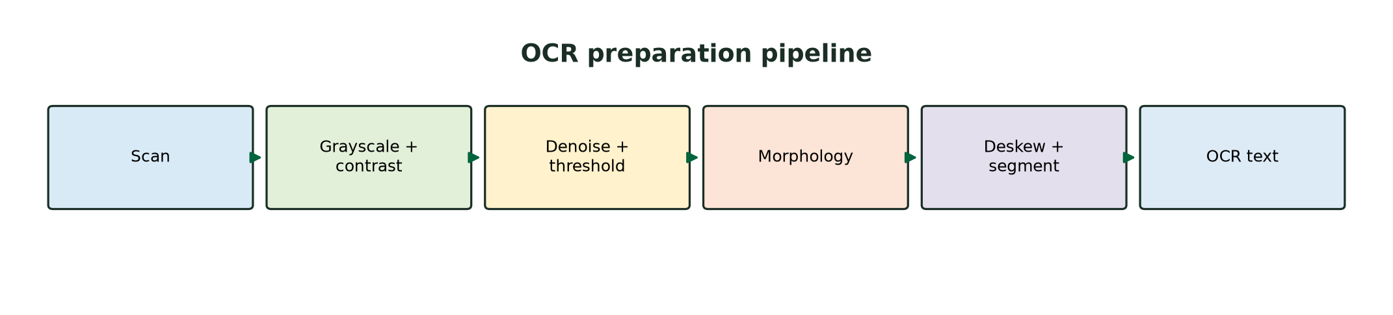
Figure 3. Document-preparation pipeline showing the transformation from scan to OCR-ready text regions.

4. Real-Time Multi-Person Tracking and Attendance System
Question: A college wants to record attendance automatically from classroom CCTV. The system must detect multiple faces, track each person, recognise registered students, avoid duplicate marking, handle head movement and temporary disappearance, and operate continuously with low delay. Design a complete system and explain identity maintenance and duplicate prevention.
Answer:
The attendance system should separate a person’s temporary track identity from the final attendance identity. A track ID says that detections in successive frames probably belong to the same visible person; a recognised student ID is assigned only after a sufficiently reliable facial match. This distinction prevents a tracker’s ID switch from directly creating a false attendance record.
Frames are captured continuously and processed at a resolution that preserves usable faces without overwhelming the computer. A classroom region of interest can exclude doors, windows, and unrelated areas. A face detector identifies all visible faces in a frame, and non-maximum suppression removes duplicate boxes. Faces that are too small, heavily blurred, strongly occluded, or outside the classroom region are marked as low quality and are not immediately used for recognition.
For each face, landmarks or eye positions support alignment, and a face-embedding model produces a normalised feature vector. The registered gallery contains multiple embeddings per student collected under realistic classroom poses. A nearest-neighbour or compact classifier returns a candidate, but the candidate is accepted only when the distance is below a threshold and the quality score is adequate. Unknown faces remain unknown; they are not assigned to the nearest student merely because a match is required.
Multi-person tracking associates detections across frames using bounding-box overlap, centroid distance, appearance similarity, and a motion model. A Kalman filter can predict the next position, while a Hungarian assignment step matches predictions to current detections. Each track stores its current bounding box, last-seen time, missed-frame count, recognition evidence, and recognition confidence. The track is kept alive for a short period during temporary face disappearance, such as a head turn or a person passing behind another student.
Identity maintenance uses temporal evidence. For example, the system can require the same student candidate to appear in at least three reliable observations within a five- to ten-second window, or require a weighted average of embedding distances to remain below the acceptance threshold. If two identities compete for one track, the system marks the track ambiguous and waits for more evidence. If a track is lost and later reappears, spatial continuity and appearance similarity can be used to reconnect it, but the system should still avoid reusing stale recognition evidence indefinitely.
Duplicate attendance is prevented with a session-level attendance register keyed by the student’s verified institutional ID. Once a student is confirmed, the system stores the first verified timestamp, camera or classroom identifier, confidence summary, and optional evidence reference. Later frames update the track’s confidence but do not create another attendance row. A re-entry policy must be explicit: if the assignment requires one mark per class, repeated appearances remain one record; if it requires entry and exit events, those are stored as separate event types.
Real-time performance is supported by detecting faces every few frames, tracking between detections, batching embeddings when several faces are present, and using a bounded processing queue. The display and logging threads should be separate from the capture loop. The system must handle camera failure, low light, and overcrowding with clear states rather than silently marking everyone absent. Evaluation should include face-detection recall, identity precision, identity switches, duplicate rate, false attendance rate, latency, and attendance completion time.
Because attendance is a consequential record, the design should include human review for low-confidence cases, clear retention rules, access controls, and a correction mechanism. The system should communicate when a student is not recognised rather than presenting an uncertain result as fact. These safeguards improve both technical reliability and the fairness of the process.
Control | Implementation | Attendance benefit
Stable track identity | IoU + centroid + motion association | Maintains continuity between frames
Recognition quality gate | Blur, size, pose, and confidence checks | Rejects unreliable face crops
Temporal confirmation | Several consistent matches | Reduces one-frame false matches
Session register | Unique student ID + first verified timestamp | Prevents duplicate attendance
Temporary disappearance | Track timeout and Kalman prediction | Handles head turns and occlusion
Human review | Ambiguous/low-confidence queue | Allows correction of uncertain cases

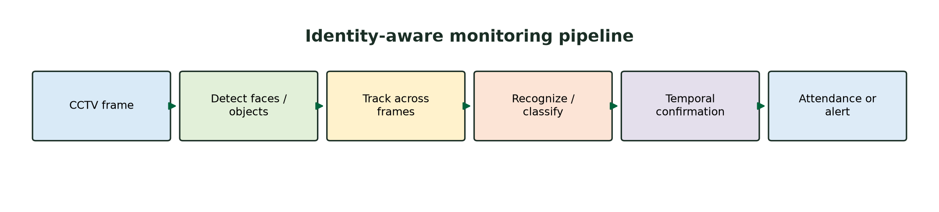
Figure 4. Identity-aware tracking pipeline for attendance, with temporal confirmation before writing a unique attendance record.

5. Smart Home Surveillance and Intrusion Detection
Question: A fixed home camera monitors an entrance continuously. The system must detect significant motion, distinguish actual movement from noise and small background changes, track moving objects, identify suspicious activity, alert on unauthorised entry into a predefined region, and operate in real time with limited resources. Design an OpenCV-based pipeline and explain how false alarms are reduced.
Answer:
The surveillance system should combine motion detection with object persistence, region-of-interest logic, and temporal rules. A single changed pixel or a short shadow should not create an intrusion alert. Instead, the system first detects candidate motion, cleans the mask, extracts objects, tracks them, and then evaluates whether a confirmed object enters the protected region or exhibits suspicious behaviour.
Video is acquired from a fixed camera with cv2.VideoCapture. The camera view is calibrated once so that the entrance and protected region can be represented by polygons. The system should ignore areas such as trees, curtains, or roads when they are not relevant to the entrance. Frames can be downscaled for motion processing, while a higher-resolution crop is saved only when an alert is confirmed.
Background subtraction with MOG2 or KNN estimates which pixels differ from the learned background. A short warm-up period allows the model to adapt before alerts are enabled. The learning rate must be controlled: if it is too high, a stationary intruder becomes part of the background; if it is too low, gradual illumination changes generate large masks. A second frame-difference check can be used to confirm that a candidate is genuinely moving rather than a stale background mismatch.
Filtering and morphology improve the foreground mask. Median or Gaussian filtering removes camera noise. Morphological opening removes isolated specks, and closing fills small holes and connects fragmented portions of a person. Contours are extracted with cv2.findContours, and each candidate is filtered by area, aspect ratio, bounding-box size, and persistence. Tiny components are ignored, while a large connected region that remains across several frames becomes a track candidate.
Shadows are reduced by using MOG2 shadow detection, comparing chromaticity with the background, and rejecting regions that mainly show a brightness decrease without a corresponding shape change. Gradual illumination changes are managed with a slowly adapting background model and an illumination-change threshold. Trees or moving foliage are handled by masking the region, using a region-specific motion threshold, and requiring a candidate to have a coherent contour and trajectory. If the whole frame changes because of camera movement, the system should suspend intrusion decisions and reinitialise the background model.
Tracking assigns an ID to each moving object and stores its centroid, bounding box, velocity estimate, last-seen time, and path. A simple centroid tracker may be enough for a low-cost device; a Kalman filter improves continuity during brief occlusion. Suspicious activity is represented by explicit rules, such as entering the protected polygon, crossing an inward boundary, remaining in the area for longer than a dwell threshold, approaching the door at night, or moving against an expected direction. These rules should require temporal confirmation rather than relying on one frame.
When an object is confirmed inside the protected region, the alert module records the time, track ID, confidence, region, and a short evidence clip or image. An alert cooldown prevents repeated notifications for the same continuous event. The display shows the foreground mask, contours, tracks, protected polygon, and current alert state. Computational limits are addressed through frame skipping, downscaled motion processing, selective high-resolution capture, small kernels, and separate capture, processing, and notification queues.
Performance should be evaluated using false alarms per hour, missed-intrusion rate, detection latency, track continuity, and processing frame rate. Testing must include day/night transitions, lamps turning on, rain, moving trees, pets, and camera vibration. The safest design is conservative: it should prefer “motion requiring review” over declaring an unauthorised person when the evidence is ambiguous, while still escalating confirmed entry into the protected region.
False-alarm source | Control strategy | Decision rule
Camera noise | Filtering + minimum area | Ignore isolated small components
Small background change | Persistence and contour checks | Require movement across several frames
Shadows | Shadow mask + chromaticity test | Reject brightness-only changes
Trees or foliage | Background adaptation + spatial mask | Exclude or raise threshold in dynamic zones
Lighting change | Slow learning rate + illumination test | Suspend/reinitialise during global change
Repeated alerts | Track ID + cooldown timer | One alert per continuous event

Overall Design Conclusion
Answer:
All five systems follow the same constraint-based engineering pattern: acquire data reliably, reduce irrelevant variation, detect candidate objects or text, maintain temporal or spatial structure, apply a confidence-based decision rule, and optimise only after measuring the computational bottlenecks. OpenCV provides the core operations for capture, filtering, morphology, contours, geometry, DNN inference, and visualisation, but the final reliability comes from threshold calibration, temporal confirmation, region restrictions, and careful handling of unknown or ambiguous cases.
For a real deployment, every system should be validated on representative local data rather than assumed to work because it performs well on a demonstration video. Accuracy, latency, memory use, false alarms, missed events, and recovery from camera failure should be reported together. This makes the solution defensible: it demonstrates not only what algorithm is used, but also how each constraint is addressed and how the system behaves when the evidence is incomplete.

